This is a Document is on how to prep a field before game time. This will be the home team’s responsibility. This is just simple guide that shows how to properly set up a field with the new chalker string system.

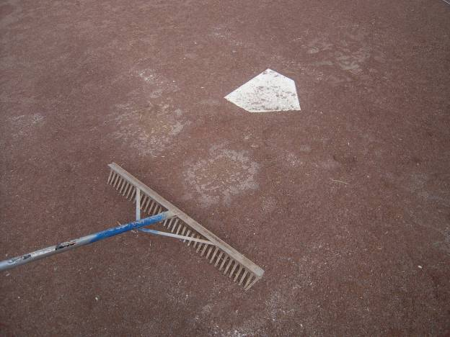

Step 1: Rake in all the holes at Home plate, first ,second , third base along with the pitchers mound. Go ahead and place the 1st ,2nd and 3rd base.
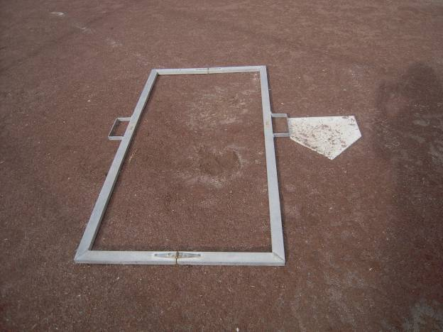

Step 2: Place batters box template as shown. Place square rectangle part on the template to line up with the sides of home plate.

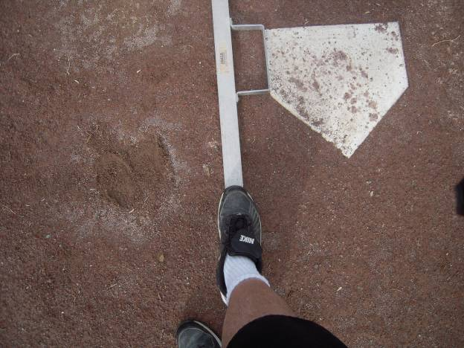
Step 3: Step on batter’s box template frame to create indentions in the dirt that you can trace with the chalker.
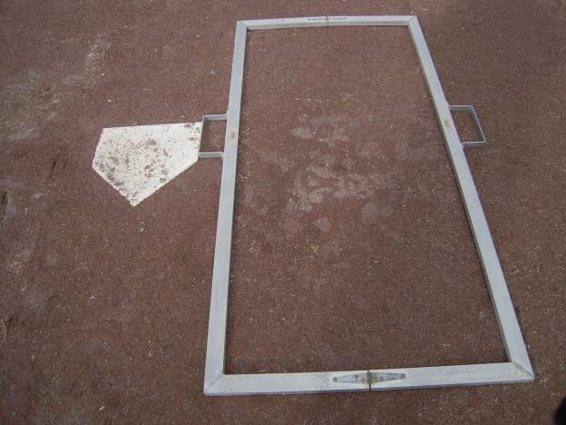
Step 4: Repeat on other side.
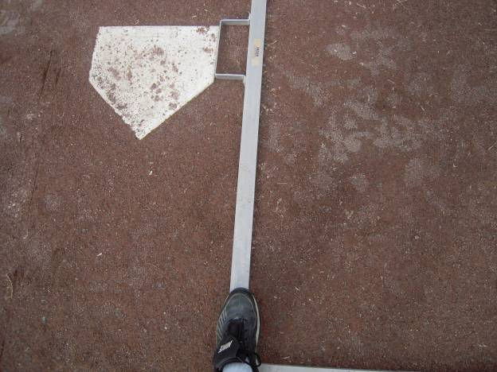
Repeat…

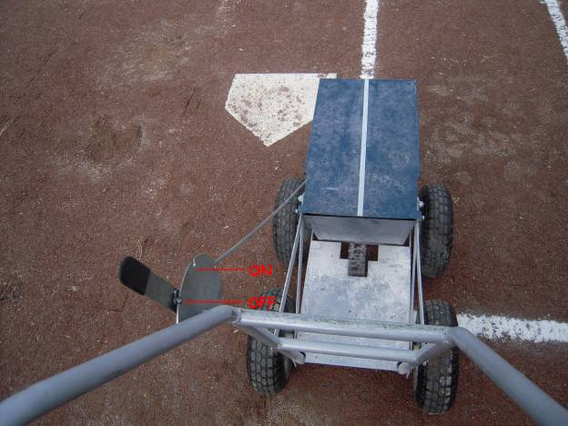
Step 6: Start chalking indention left by the batter’s box template. Move the lever on the chalker to the on position when ready to chalk. Move lever to off position when you do not want any chalk to dispense.

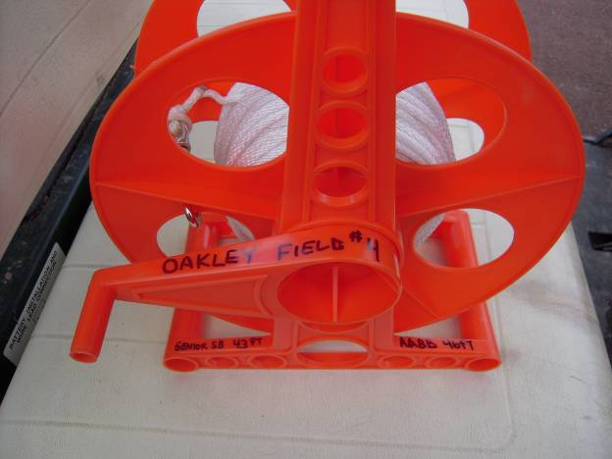

Step 7: Once both batters boxes are done grab the chalk line string for the foul ball lines.

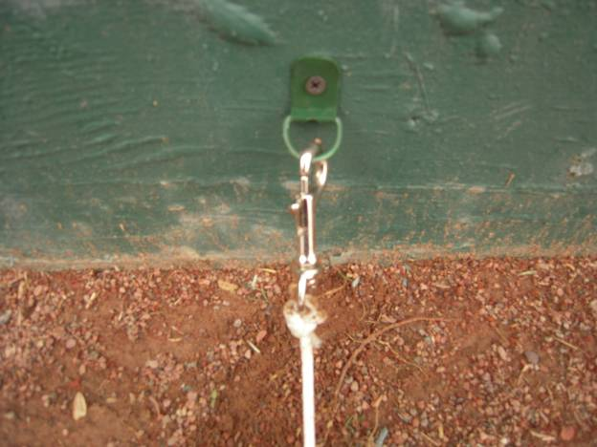
Step 8: Connect the quick snap connector to the D – ring located on the backstop.
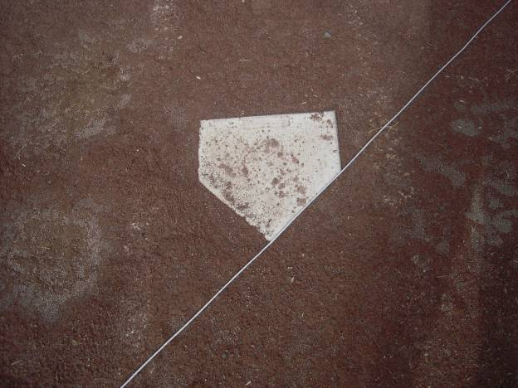
Step 9: Pull the chalk line across home plate all the way down to the 1st or 3rd base side with the bases in.
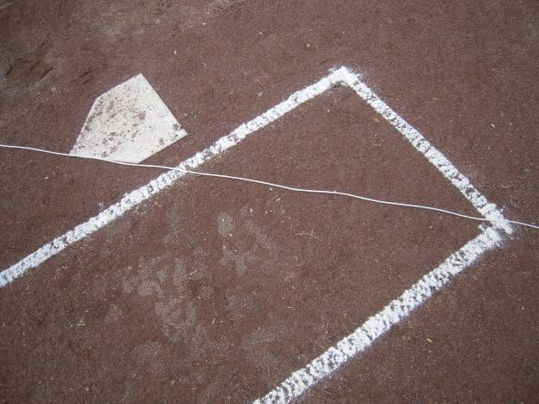

The chalk line should look like this… going across home plate… But the string should be a lot tighter than this…
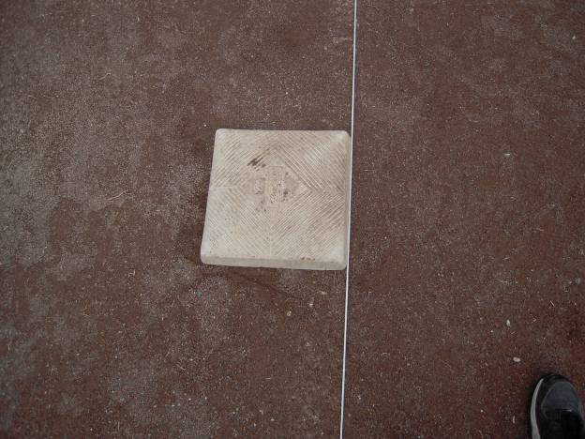
With the foul line on the out side of the base. Leaving the base in fair play territory, the chalk line should look like this.

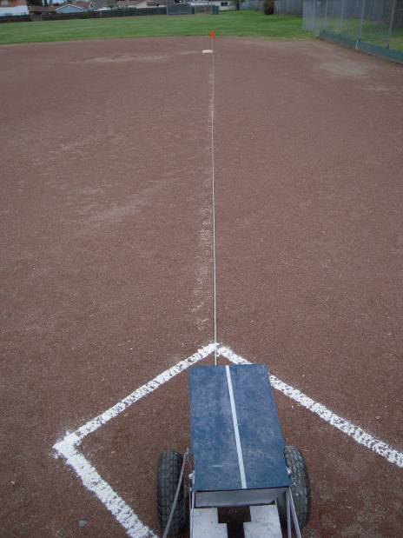

Step 10: Get ready to chalk… Start from the corner of the batters box closest to the base and work your way down following the chalk line string.
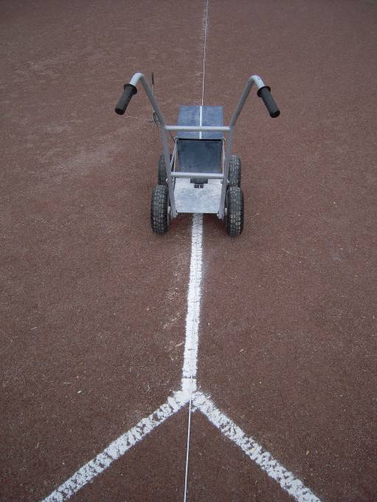
The foul line should start looking like this.

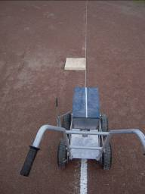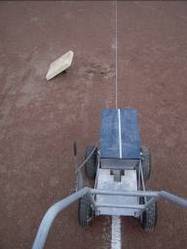
When you get to 1st and or 3rd base don’t go over the base.. Simply pull the base set it to the side… Continue to chalk….

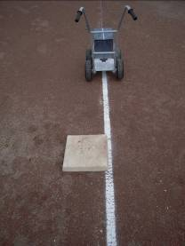

Then reset the base…..

Then continue the chalk line all the way out to the grass..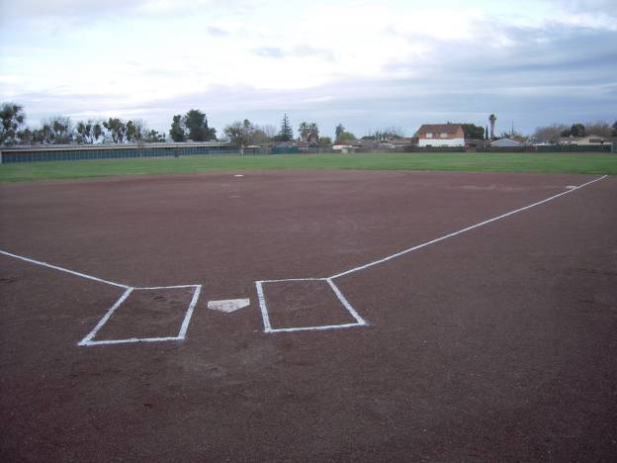

Once you are done on the First Base side Repeat all the steps for 3rd base. Move the quick snap connector to the other side of the back stop and pull your string tightly down past 3rd base keeping the base in fair territory.

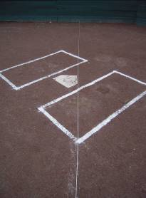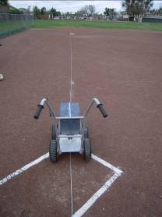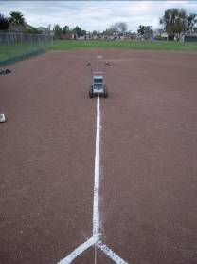

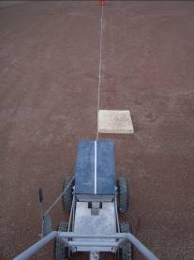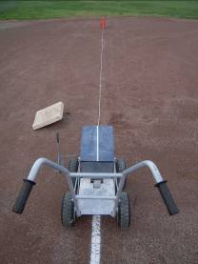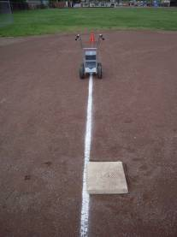
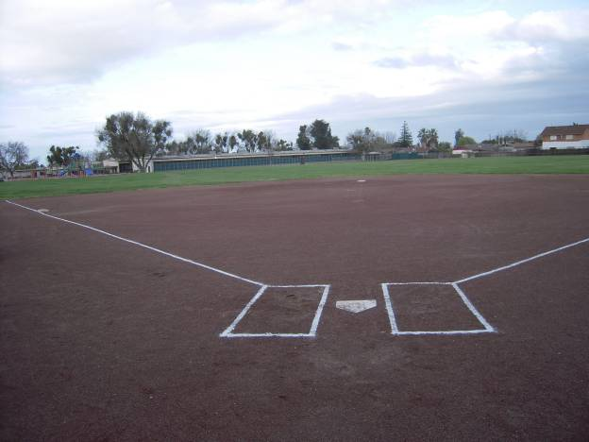

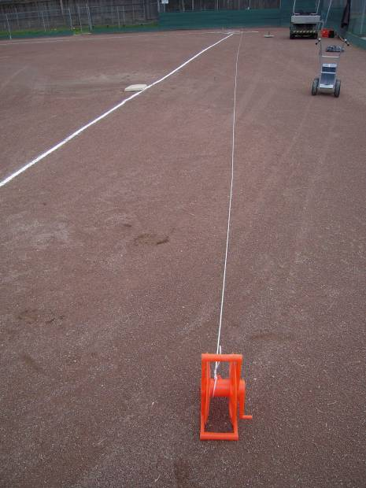
When you are all done wind up the chalk line string back on to the wheel and place back into the storage can for the next team to use the following day.

OAKLEY FIELD 4 AND OAKLEY FIELD 6 KEEP ON READING BELOW
OAKLEY FIELD 4 INSTRUCTIONS ONLY

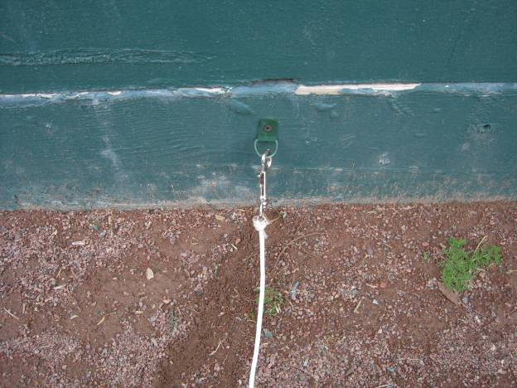
I have place an additional D- Ring clip right behind home plate. This will be used for the Senior Softball and AA Baseball teams pitchers mounds.
Keep reading below

I have pre-measured the distances for Senior Softball from the point on home plate at 43ft and marked it with a piece of tape. This is to the front edge of the stake in mound for senior softball.
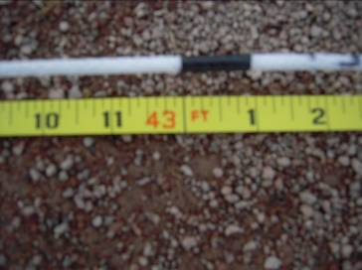
I also pre-measured for AA Baseball 46ft and also marked with a piece of tape for the front edge of the mound.

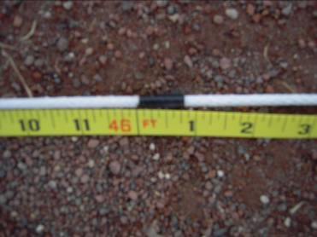

There are also two refrence points labled with black tape one is at home plate and the other is 2nd base. With these two marks you will be able to adjust the pitchers mounds accordiangly.
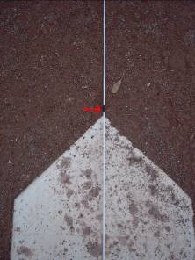

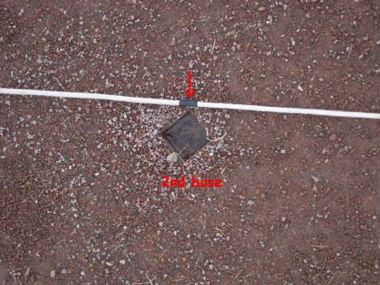
OAKLEY FIELD 6 READ BELOW
OAKLEY FIELD 6 (T-BALL)
On field 6 there are throw down bases that are located in the storage box located behind home plate. In the storage box your chalk line string is also measured out and labled for 50ft bases. You will use the quick snap connector and clip on to the back stop cyclone fence as shown below.

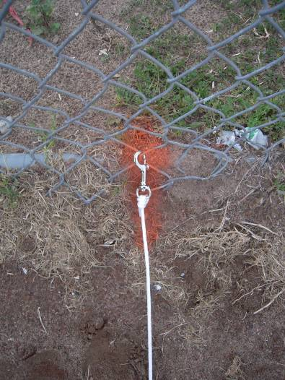
Clip here and run your chalk line string past home plate down the 1st and 3rd base lines.

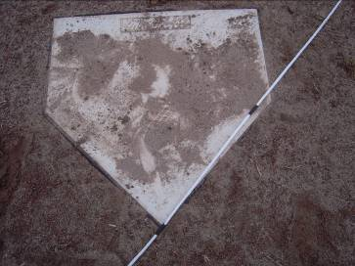
Down 1st base with 2 refrence points.

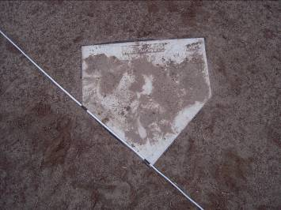
Down 3rd base with refrence points.

There is a piece of black tape that has been pre measured for 50ft that you will be able to place your bases accordiangly at those marks.
If there is any problems during the season with either the D-ring clips or chalker lines please feel free to reach out to Mike Rosalez @ mrosalez@comcast.net

